Process Document | Website:Hobup.com  Task Name: Hobup Data Model
Document Version No : 1.0
Release Date : 10/01/2013
Released/ Updated by :Madan Kumar

Revision History
[The version number on the cover page, in the header, and the last entry in the Revision History table must always match. The initial version number is always 0.01 just as the template is set up. When there is more than one author, the authors’ names are separated by a slash “/.”]
Version Number | Date | Description | Author
1.0 | 10/01/2013 | Initial Release | Madan Kumar
1.1 | 10/08/2013 | Updated Registration, Login, Hobby Selection Modules | Karthik / Somuraja
1.2 | 10/12/2013 | Updated User Profile Module | Karthik / Somuraja
1.3 | 10/20/2013 | Updated Registration,Login,Hobby Selection,User Profile Module | Karthik/ Somuraja
1.4 | 10/26/2013 | Changes in Data type | Karthik/Somuraja
1.5 | 10/28/2013 | Inserted Browser field data in Login Module | Karthik/Somuraja
1.6 | 10/28/2013 | Updated Post and Blog Profile Module | Karthik/Somuraja
1.7 | 11/18/2013 | Updated Friends Module | Karthik/Somuraja

Contents
Hobup Data Model 5
1. Introduction 5
2. Scope of work 5
3. Major Table System Identification 5
4. User Data Types 6
Registration Module 9
I. Registration Data Dictionary 9
Description 11
II. Registration Schema 13
Login Module 13
I. Login Data Dictionary 13
Description 15
II. Login Schema 16
Hobby Selection Module 16
I. Hobby Selection Data Dictionary 16
Description 18
II. Hobby Selection Schema 19
SQL query for the above modules 19
User profile Module 24
I. User profile Data Dictionary 24
Description 25
II. User Profile Selection Schema 26
SQL query for the above table 26
Post and Blog Module 27
I. Post and Blog Data Dictionary 27
Description 31
II. Post and Blog Schema 32
SQL query for the above table 33
Friends Module 37
I. Friends Data Dictionary 37
Description 39
II. Friends Schema 40
SQL query for the above table 40

Hobup Data Model

Introduction

Hobup is a site which helps or attracts people to focus on their hobbies and live a healthy and happy life. This Hobby site shall act as a hub for mutually interested hobby friends and families to get together. This document will discuss about the complete data model for hobup.

Scope of work

- Major Table System Identification for identifying a table
- Defining the user data types
- Defining data dictionary for the tables
- Displaying Schema diagrams for the tables

Major Table System Identification
Identifier | Description
User_ Role | User Role
User_ Status | User Status
User_ Referrer | User Signup method
User | User Registration
User_ Activity | User Activity
User_ Log | User Session
Hob | Hobbies
User_ Hob | User Hobbies
User_Profile | User profile
Category | Category of the message
Post_Type | Post type
Post | Post table
Image_Master | Image master table
Post_Images | Image posting table
Video_Master | Video master table
Post_Videos | Video posting table
Friends | Table to store friends
Friends_Status | Table for Status of friend
Friends_Request | Table for giving request to friend

User Data Types
UserType | SQLSQL Data Type | Maxmax_length
User_ Role_ id | int | 4
User_ Role_ desc | varchar | 50
User_ Status_ id | smallint | 2
User_ Status_ desc | varchar | 50
User_ Referrer_ id | smallint | 2
User_ Referrer_ name | varchar | 50
User_ id | bigint unique Auto increment | 8
User_ email | varchar Unique | 100
User_ firstname | varchar | 50
User_ lastname | varchar | 50
User_ password | varchar | 100
User_ dateofbirth | datetime
User_gender | boolean
User_path | varchar | 150
User_img | varchar | 150
User_salt | varchar | 100
User_ signup_token | varchar null | 50
User_ Activity_ id | int | 4
User_ Activity _ action | varchar | 50
User_ Log_ id | bigint | 8
User_ Log _ timedate | datetime
User_ Log _ ipaddress | varchar null | 50
User_Log_browser | varchar | 50
Hob_ id | int | 4
Hob_ hobbylist | text
Hob_ image | varchar | 150
User_Profile_id | bigint | 8
User_profile_location | varchar | 50
User_Profile_livesin | varchar | 50
User_Profile_from | varchar | 50
User_Profile_mobile | varchar | 50
User_Profile_country | varchar | 50
User_Profile_aboutme | text
User_Profile_coverimage | varchar | 150
User_ createdts | timestamp
User_ updatedts | timestamp
Category_id | smallint AutoIncrement | 2
Category_desc | varchar | 50
Post_Type_id | smallint AutoIncrement | 2
Post_Type_desc | varchar | 50
Post_Type_tablename | varchar | 50
Post_id | bigint AutoIncrement | 8
Post_message | text
Image_Master_id | bigint AutoIncrement | 8
Image_Master_name | varchar | 100
Post_Images_id | bigint AutoIncrement | 8
Video_Master_id | bigint AutoIncrement | 8
Video_Master_name | varchar | 100
Post_Videos_id | bigint AutoIncrement | 8
Friends_userid1 | bigint | 8
Friends_userid2 | bigint | 8
Friends_Status_id | int | 4
Friends_Status_desc | varchar | 50
Friends_Request_id | bigint | 8
Friends_Request_message | text

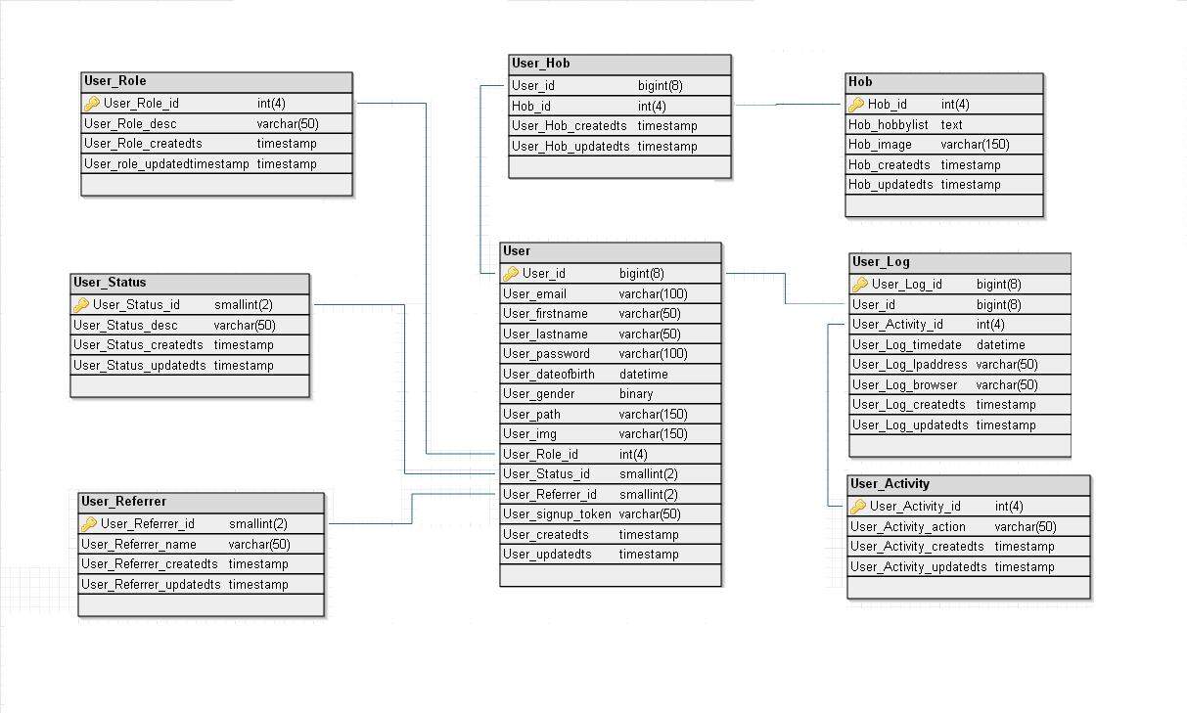

Registration Module

Registration Data Dictionary
Table Name | Column Name | Data Type | Comment
User_ Role | User_ Role_ id (PK) | int | User Role id is the Primary Key of this table
 | User_ Role_ desc | varchar | This field indicates the user role such as admin, manager or normal user.
 | User_Role_createdts | timestamp | This field indicates the user role created time
 | User_Role_updatedts | timestamp | This indicates user role updated time
User_ Status | User_ Status_ id (PK) | smallint | User Status id is the Primary Key of this table
 | User_ Status_ desc | varchar | This field shows the user’s current status whether he/she is active, inactive or pending
 | User_Status_createdts | timestamp | This indicates the user status time
 | User_Status_updatedts | timestamp | This indicates the user status updated time
User_ Referrer | User_ Referrer_ id (PK) | smallint | User referrer id is the Primary Key of this table
 | User_ Referrer_ name | varchar | This field contains where from the user get registered such as Hobup or using other options like Facebook or Google+
 | User_Referrer_createdts | timestamp | This field indicates the user referrer profile created time
 | User_Referrer_updatedts | timestamp | This field indicates the user referrers updated time
User | User_ id (Auto – Increment)(PK) | bigint | User id is the primary key for this table
 | User_ email (UNIQUE) | varchar | This field is the Unique Key of this table.  It has email id of the users who get registered
 | User_ firstname | varchar | First name of user
 | User_ lastname | varchar | Last name of user
 | User_ password | varchar | This stores the password given by the user in encrypted form
 | User_ dateofbirth | datetime | Users Specified Date of Birth and it is stored in date time format such as 05/06/1989
 | User_gender | boolean | This field indicates the gender of the user
 | User_path (UNIQUE) | varchar | This field indicates the path of the profile image and unique key for this table
 | User_img | varchar | This field denotes the users profile image
 | User_ Role_ id (FK) | int | This is Foreign Key of the User table and Primary Key of User role Table.
 | User_ Status_ id (FK) | smallint | This is Foreign Key of the User table and Primary Key of User Status Table.
 | User_ Referrer_ id (FK) | smallint | This is Foreign Key of the User table and primary key in user Referrer Table.
 | User_salt | varchar | This field is used for safety of encrypted passwords
 | User_ signup_token | varchar | If the user is registered from other sites, then Unique Id which provided by that specific site through API. This field stores those unique ids here.
 | User_ createdts | timestamp | This field stores the time of user profile creation.
 | User_updatets | timestamp | This field stores the time information regarding the user updates.

Description

Registration Module currently has 5 Tables
- User_ Role - The purpose of this table is to identify the role of the user whether he is a user or an admin. In future we can add user roles from Hobup Admin panel.

- User_ Status - The purpose of this table is to indicate whether the user is in active, inactive or in pending state. In future we can add user status from Hobup Admin panel.

- User_ Referrer - The purpose of this table is to store the details from where the user gets registered (By email, facebook or by twitter). In future we can add user signup from Hobup Admin panel.

- Gender- The purpose of this table is to identify the gender of the user.

- User- This is the Basic Table of Hobup. The purpose of this table is to store the credential information of the registered users. This table stores Primary key value of four other tables as Foreign Key. In addition to this date and time of profile created is stored. This table is used while the users login.

Registration Schema
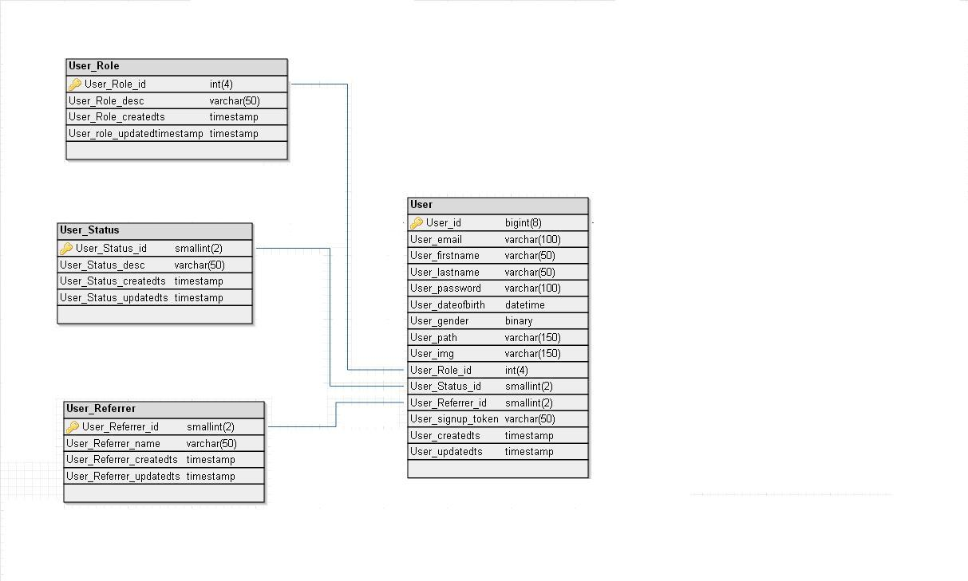

Login Module

Login Data Dictionary
Table Name | Column Name | Data Type | Comment
User_ Activity | User_ Activity_ id(PK) | int | This field is the Primary Key of this table.
 | User_ Activity_ action | varchar | This field has set of user activities such as Login, Logout, Password updated, Profile updated, etc
 | User_Activity_createdts | timestamp | This just creates the time for user activities such as sharing, posting blogs
 | User_Actiity_updatedts | timestamp | This just updates the time of doing some activities
User_ Log | User_ Log_ id(PK) | bigint | This field is the Primary Key of this table.
 | User_ id(FK) | bigint | This is Foreign Key of the User Login table and Primary Key of User Table.
 | User_ Activity_ id(FK) | int | This is Foreign Key of the User Login table and Primary Key of User Activity table.
 | User_ Log_ timedate | datetime | Stores current date and time details
 | User_ Log_ Ipaddress | varchar | Stores User IP Address
 | User_Log_browser | varchar | This gives the information about which browser user is using
 | User_Log_createdts | timestamp | This field is used to store the time for his login logout session
 | User_Log_updatedts | timestamp | This field is used to update the log session of the user

Description

Login Module currently has 2 Tables

- USER_ ACTIVITY- The purpose of this table is to store the activities of the user after he logs in. The activities include account settings, profile settings.
- USER_ LOG- The purpose of this table is to store the session information like the changes made in the profile or in the account and stores the IP address of the end device. It also stores the current date and time and also time information regarding login.

Login Schema

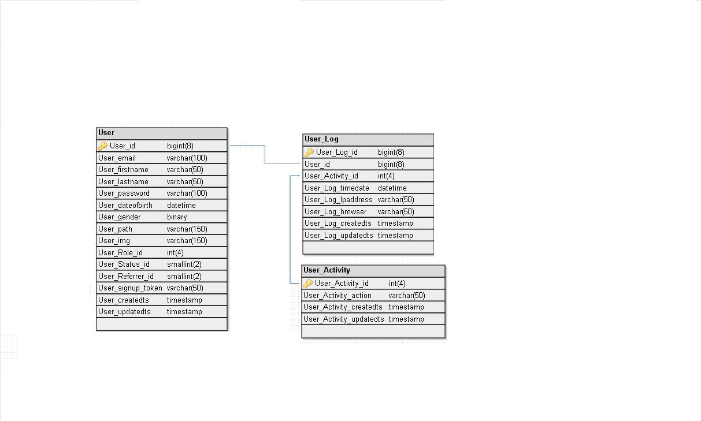

Hobby Selection Module

Hobby Selection Data Dictionary
Table Name | Column Name | Data Type | Comment
Hob | Hob_ id (PK) | int | This field is the Primary Key of this table.
 | Hob_ hobbylist | text | This field stores List of hobbies
 | Hob_ image | varchar | This field contains hobbies display Image names or path
 | Hob_createdts | timestamp | This field is used to tell about the time hobby is created
 | Hob_updatedts | timestamp | This field is to give details when the hobby is updated
User_ Hob | User_ id(FK) | bigint | This field is Primary Key for User hob table and Unique key for User table. This field contains the user id from the user table
 | Hob_ id (FK) | int | This field is Primary Key for both User hobby table and Hob table. This field contains the hobbies id from the hob table
 | User_Hob_createdts | timestamp | This field is used to store when the user selected hobby
 | User_Hob_updatedts | timestamp | This field is used to update when the user has selected hobby

Description
Hobby Selection Module currently has 2 Tables.
- Hob - HOBBIES table stores the list of all hobbies such as sports, music, singing, movies.
- User_ Hob - USER HOBBIES table stores the user selected hobbies for each users .Using this table we can fetch all hobbies of the single user.

Hobby Selection Schema

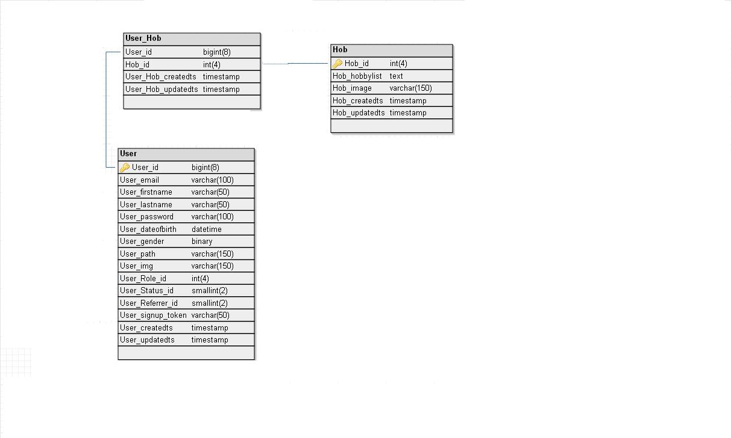

SQL query for the above modules

CREATE TABLE IF NOT EXISTS `User_Role` (
`User_Role_id` int (4) NOT NULL AUTO_INCREMENT,
`User_Role_desc` varchar (50) DEFAULT NULL,
`User_Role__createdts` timestamp NOT NULL DEFAULT '0000-00-00 00:00:00',
`User_Role_updatedts` timestamp NOT NULL DEFAULT CURRENT_TIMESTAMP ON UPDATE CURRENT_TIMESTAMP,
PRIMARY KEY (`User_Role_id`)
);
CREATE TABLE IF NOT EXISTS `User_Status` (
`User_Status_id` smallint (2) NOT NULL AUTO_INCREMENT,
`User_Status_desc` varchar (50) DEFAULT NULL,
`User_Status__createdts` timestamp NOT NULL DEFAULT '0000-00-00 00:00:00',
`User_Status__updatedts` timestamp NOT NULL DEFAULT CURRENT_TIMESTAMP ON UPDATE CURRENT_TIMESTAMP,
PRIMARY KEY (`User_Status_id`)
);
CREATE TABLE IF NOT EXISTS `User_Referrer` (
`User_Referrer_id` smallint (2) NOT NULL AUTO_INCREMENT,
`User_Referrer_name` varchar (50) DEFAULT NULL,
`User_Referrer_createdts` timestamp NOT NULL DEFAULT '0000-00-00 00:00:00',
`User_Referrer_updatedts` timestamp NOT NULL DEFAULT CURRENT_TIMESTAMP ON UPDATE CURRENT_TIMESTAMP,
PRIMARY KEY (`User_Referrer_id`)
);

CREATE TABLE IF NOT EXISTS `User` (
`User_id` bigint (8) NOT NULL AUTO_INCREMENT,
`User_email` varchar (100) NOT NULL,
`User_firstname` varchar (50) DEFAULT NULL,
`User_lastname` varchar (50) DEFAULT NULL,
`User_password` varchar (100) DEFAULT NULL,
`User_dateofbirth` datetime DEFAULT NULL,
`User_gender` TINYINT (1) NOT NULL,
`User_path` varchar (150) NOT NULL,
`User_img` varchar (150) DEFAULT NULL,
`User_Role_id` int (4) DEFAULT NULL,
`User_Status_id` smallint (2) DEFAULT NULL,
`User_Referrer_id` smallint (2) DEFAULT NULL,
`User_salt` varchar(100) DEFAULT NULL,
`User_signup_token` varchar (50) DEFAULT NULL,
`User_createdts` timestamp NOT NULL DEFAULT '0000-00-00 00:00:00',
`User_updatedts` timestamp NOT NULL DEFAULT CURRENT_TIMESTAMP ON UPDATE CURRENT_TIMESTAMP,
PRIMARY KEY (`User_id`),
UNIQUE KEY `User_email` (`User_email`),
UNIQUE KEY `User_path` (`User_path`),
KEY `User_fk1` (`User_Role_id`),
KEY `User_fk2` (`User_Status_id`),
KEY `User_fk3` (`User_Referrer_id`)
);
CREATE TABLE IF NOT EXISTS `User_Activity` (
`User_Activity_id` int (4) NOT NULL AUTO_INCREMENT,
`User_Activity_action` varchar (50) DEFAULT NULL,
`User_Activity_createdts` timestamp NOT NULL DEFAULT '0000-00-00 00:00:00',
`User_Activity_updatedts` timestamp NOT NULL DEFAULT CURRENT_TIMESTAMP ON UPDATE CURRENT_TIMESTAMP,
PRIMARY KEY (`User_Activity_id`)
);
CREATE TABLE IF NOT EXISTS `User_Log` (
`User_Log_id` bigint (8) NOT NULL AUTO_INCREMENT,
`User_id` bigint (8) DEFAULT NULL,
`User_Activity_id` int (4) DEFAULT NULL,
`User_Log_timedate` datetime DEFAULT NULL,
`User_Log_ipaddress` varchar (50) DEFAULT NULL,
`User_Log_browser` varchar(50) DEFAULT NULL,
`User_Log_createdts` timestamp NOT NULL DEFAULT '0000-00-00 00:00:00',
`User_Log_upatedts` timestamp NOT NULL DEFAULT CURRENT_TIMESTAMP ON UPDATE CURRENT_TIMESTAMP,
PRIMARY KEY (`User_Log_id`),
KEY `User_Log_fk1` (`User_id`),
KEY `User_Log_fk2` (`User_Activity_id`)
);
CREATE TABLE IF NOT EXISTS `Hob` (
`Hob_id` int (4) NOT NULL AUTO_INCREMENT,
`Hob_hobbylist` TEXT DEFAULT NULL,
`Hob_image` varchar (150) DEFAULT NULL,
`Hob_currentts` timestamp NOT NULL DEFAULT '0000-00-00 00:00:00',
`Hob_updatedts` timestamp NOT NULL DEFAULT CURRENT_TIMESTAMP ON UPDATE CURRENT_TIMESTAMP,
PRIMARY KEY (`Hob_id`)
);

CREATE TABLE IF NOT EXISTS `User_Hob` (
`User_id` bigint (8) NOT NULL,
`Hob_id` int (4) NOT NULL,
`User_Hob_createdts` timestamp NOT NULL DEFAULT '0000-00-00 00:00:00',
`User_Hob_updatedts` timestamp NOT NULL DEFAULT CURRENT_TIMESTAMP ON UPDATE CURRENT_TIMESTAMP,
KEY `User_Hob_fk1` (`User_id`),
KEY `User_Hob_fk2` (`Hob_id`)
);
ALTER TABLE `User`
ADD CONSTRAINT `User_fk1` FOREIGN KEY (`User_Role_id`) REFERENCES `User_Role` (`User_Role_id`),
ADD CONSTRAINT `User_fk2` FOREIGN KEY (`User_Status_id`) REFERENCES `User_Status` (`User_Status_id`),
ADD CONSTRAINT `User_fk3` FOREIGN KEY (`User_Referrer_id`) REFERENCES `User_Referrer` (`User_Referrer_id`);

ALTER TABLE `User_Log`
ADD CONSTRAINT `User_Log_fk1` FOREIGN KEY (`User_id`) REFERENCES `User` (`User_id`),
ADD CONSTRAINT `User_Log_fk2` FOREIGN KEY (`User_Activity_id`) REFERENCES `User_Activity` (`User_Activity_id`);

ALTER TABLE `User_Hob`
ADD CONSTRAINT `User_Hob_fk1` FOREIGN KEY (`User_id`) REFERENCES `User` (`User_id`),
ADD CONSTRAINT `User_Hob_fk2` FOREIGN KEY (`Hob_id`) REFERENCES `Hob` (`Hob_id`);

User profile Module

User profile Data Dictionary

Table Name | Column Name | Data Type | Comment
User_Profile | User_Profile_id(PK) | bigint | This field indicates the user profile id.
 | User_id(FK) | bigint | This field is used to specify the user-id.
 | User_Profile_location | varchar | This field represents where the user is located.
 | User_id_livesin | varchar | This field is used to represent where the user currently lives in.
 | User_Profile_from | varchar | This field is used to represent the native place of the user.
 | User_Profile_mobile | varchar | This field is used to represent the mobile number of the user.
 | User_Profile_country | varchar | This field is used to represent the country of the user
 | User_Profile_aboutme | text | This field represents the description about the user
 | User_Profile_coverimage | varchar | This field represents the cover image of the user profile
 | User_ Profile_createdts | timestamp | This field represents the creation of user profile.
 | User_ Profile_updatedts | timestamp | This field represents the time of update of user profile.

Description

User_Profile-This t able is used to store all the information about the user like where he was born and his native place and current residential status etc. With the help of this the other users will come to know about him.

User Profile Selection Schema

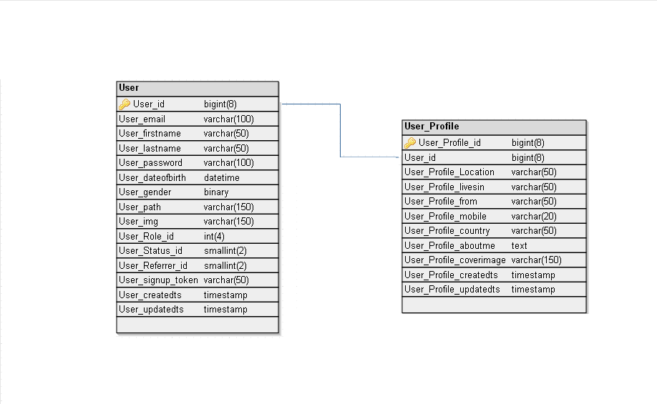

SQL query for the above table

CREATE TABLE IF NOT EXISTS `User_Profile`
(
`User_Profile_id ` bigint (8) NOT NULL AUTO_INCREMENT,
`User_id` BIGINT (8) DEFAULT NULL,
`User_Profile_location` varchar (50) DEFAULT NULL,
`User_Profile_livesin` varchar (50) DEFAULT NULL,
`User_Profile_from` varchar (50) DEFAULT NULL,
`User_Profile_country` varchar (50) DEFAULT NULL,
`User_Profile_mobile` varchar (50) DEFAULT NULL,
`User_Profile_aboutme` text DEFAULT NULL,
`User_Profile_coverimage` varchar (150) DEFAULT NULL,
`User_Profile_createdts` TIMESTAMP NOT NULL DEFAULT '0000-00-00 00:00:00',
`User_Profile_updatedts` TIMESTAMP NOT NULL DEFAULT CURRENT_TIMESTAMP ON UPDATE CURRENT_TIMESTAMP,
PRIMARY KEY (`User_Profile_id`)
);

ALTER TABLE `User_Profile` ADD CONSTRAINT `User_Profile_fk1` FOREIGN KEY (`User_id`) REFERENCES User (`User_id`);

Post and Blog Module

Post and Blog Data Dictionary

Table Name | Column Name | Data Type | Comment
Category | Category_ id (PK) | smallint | Category id is the primary Key of this table.
 | Category_desc | varchar | This field indicates selection whether it is a post or a blog
 | Category_createdts | timestamp | This displays the created time for that category
 | Category_ updatedts | timestamp | This displays the updated time for the category
Post_Type | Post_Type_id(PK) | smallint | Post type id is the primary key of this table
 | Post_Type_desc | varchar | This field indicates what type of post the user wants to post in profile
 | Post_Type_tablename | varchar | This field indicates the table for every category of post
 | Post_Type_createdts | timestamp | This displays the created time for the type of post
 | Post_Type_updatedts | timestamp | This displays the updated time for post type
Post | Post_id(PK) | bigint | Post id is the primary key for this table
 | User_id(FK) | bigint | User id is the foreign key for this table
 | Post_message | text | This field indicates the users message to be posted
 | Category_id(FK) | smallint | This is foreign key for this table to know whether it is a post or blog
 | Post_createdts | timestamp | This indicates the time of creation of post
 | Post_updatedts | timestamp | This field indicates the updated time for the post
Image_Master | Image_Master_id(PK) | bigint | This field is the primary key for this table
 | User_id(FK) | bigint | This refers to the user id and it is foreign key here.
 | Image_Master_name | varchar | This indicates the name of the image
 | Image_Master_createdts | timestamp | This just stores the image created time
 | Image_Master_updatedts | timestamp | This just gives updates about the images here
Post_Images | Post_Images_id(PK) | bigint | This field is the primary key for this table
 | Post_id(FK) | bigint | This represents the post id and it is a foreign key here
 | Image_Master_id(FK) | bigint | This is used to indicate the image master id from the master table and it is a foreign key for this table
 | Post_Images_createdts | timestamp | This just displays the time when the image is posted
 | Post_Images_updatedts | timestamp | This just updates when the user posted last image
Video_Master | Video_Master_id(PK) | bigint | This field indicates the primary key for this table
 | User_id(FK) | bigint | This refers to the user id and it is the foreign key here
 | Video_Master_name | varchar | This indicates the name for the video
 | Video_Master_createdts | timestamp | This just stores information when the video is uploaded
 | Video_Master_updatedts | timestamp | This just updates the time video is stored here
Post_Videos | Post_Videos_id(PK) | bigint | This field is the primary key for this table
 | Post_id(FK) | bigint | This field indicates the id for the post and it is a foreign key for this table
 | Video_Master_id(FK) | bigint | This is used to indicate the video master id from the master table and it is a foreign key for this table
 | Post_Videos_createdts | timestamp | This stores the time when the video is posted
 | Post_Videos_updatedts | timestamp | This just updates the video posted time

Description

- Category- This table shows the type of user given data as post or blog.

- Post_Type-This field indicates what type of post the user want to post (like smiley,image,video)

- Post-This table is used to display the user given data with respect to the user id and post id.

- Image_Master-This is the master table for image storage. The user specified images are stored here with respect to the corresponding user id.

- Post_Images-This table is used to replace the original name of the image to the corresponding post id.

- Video_Master-This is the master table for video storage. The user specified videos are stored here with respect to the corresponding user id.

- Post_Videos-This table is used to replace the original name of the video to their corresponding post id.

Post and Blog Schema

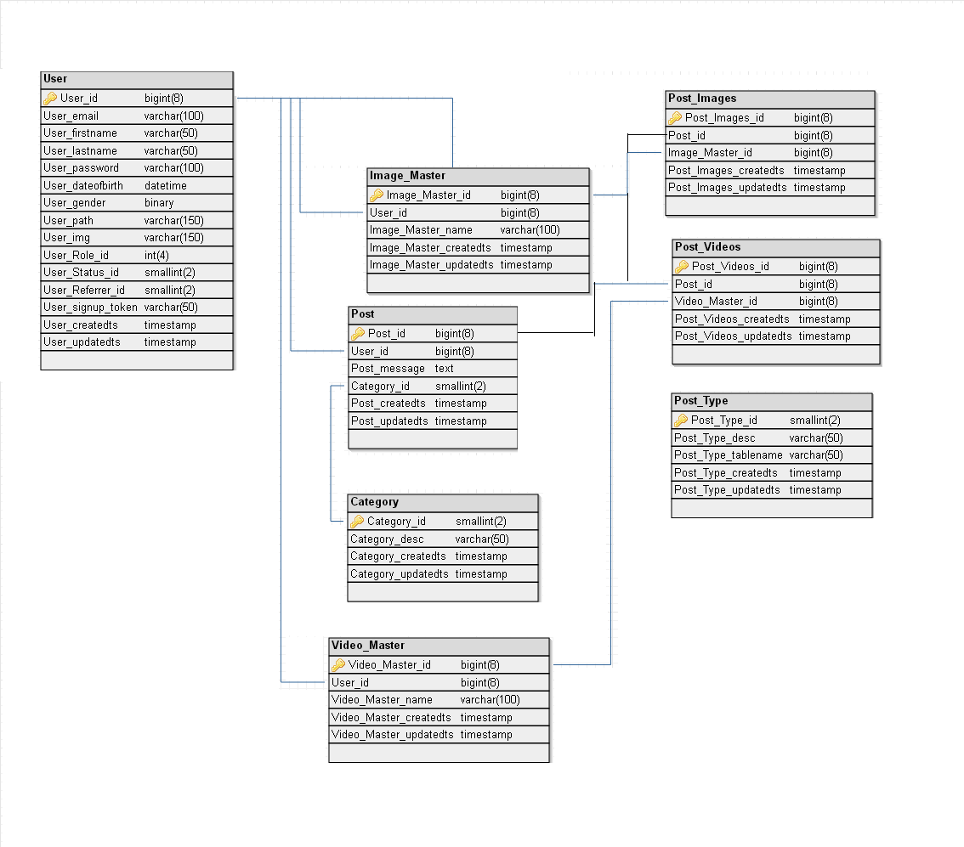

SQL query for the above table

CREATE TABLE `Category` (
`Category_id` SMALLINT (2) NOT NULL AUTO_INCREMENT,
`Category_desc` VARCHAR (50),
`Category_createdts` TIMESTAMP NOT NULL DEFAULT '0000-00-00 00:00:00',
`Category_updatedts` TIMESTAMP NOT NULL DEFAULT CURRENT_TIMESTAMP ON UPDATE CURRENT_TIMESTAMP,

PRIMARY KEY (`Category_id`)
);

CREATE TABLE `Post_Type` (
`Post_Type_id` SMALLINT (2) NOT NULL AUTO_INCREMENT,
`Post_Type_desc` VARCHAR (50),
`Post_Type_tablename` VARCHAR (50),
`Post_Type_createdts` TIMESTAMP NOT NULL DEFAULT '0000-00-00 00:00:00',
`Post_Type_updatedts` TIMESTAMP NOT NULL DEFAULT CURRENT_TIMESTAMP ON UPDATE CURRENT_TIMESTAMP,

PRIMARY KEY (`Post_Type_id`)
);

CREATE TABLE `Post` (
`Post_id` BIGINT (8) NOT NULL AUTO_INCREMENT,
`User_id` BIGINT (8),
`Post_message` TEXT DEFAULT NULL,
`Category_id` SMALLINT (2),
`Post_createdts` TIMESTAMP NOT NULL DEFAULT '0000-00-00 00:00:00',
`Post_updatedts` TIMESTAMP NOT NULL DEFAULT CURRENT_TIMESTAMP ON UPDATE CURRENT_TIMESTAMP,

PRIMARY KEY (`Post_id`),
KEY `Post_fk1` (`User_id`),
KEY `Post_fk2` (`Category_id`)
);

CREATE TABLE `Image_Master` (
`Image_Master_id` BIGINT (8) NOT NULL AUTO_INCREMENT,
`User_id` BIGINT (8),
`Image_Master_name` VARCHAR (100),
`Image_Master_createdts` TIMESTAMP NOT NULL DEFAULT '0000-00-00 00:00:00',
`Image_Master_updatedts` TIMESTAMP NOT NULL DEFAULT CURRENT_TIMESTAMP ON UPDATE CURRENT_TIMESTAMP,

PRIMARY KEY (`Image_Master_id`),
KEY `Image_Master_fk1` (`User_id`)
);

CREATE TABLE `Post_Images` (
`Post_Images_id` BIGINT (8) NOT NULL AUTO_INCREMENT,
`Post_id` BIGINT (8),
`Image_Master_id` BIGINT (8),
`Image_Master_createdts` TIMESTAMP NOT NULL DEFAULT '0000-00-00 00:00:00',
`Image_Master_updatedts` TIMESTAMP NOT NULL DEFAULT CURRENT_TIMESTAMP ON UPDATE CURRENT_TIMESTAMP,

PRIMARY KEY (`Post_Images_id`),
KEY `Post_Images_fk1` (`Post_id`),
KEY `Post_Images_fk2` (`Image_Master_id`)
);

CREATE TABLE `Video_Master` (
`Video_Master_id` BIGINT (8) NOT NULL AUTO_INCREMENT,
`User_id` BIGINT (8),
`Video_Master_name` VARCHAR (100),
`Video_Master_createdts` TIMESTAMP NOT NULL DEFAULT '0000-00-00 00:00:00',
`Video_Master_updatedts` TIMESTAMP NOT NULL DEFAULT CURRENT_TIMESTAMP ON UPDATE CURRENT_TIMESTAMP,

PRIMARY KEY (`Video_Master_id`),
KEY `Video_Master_fk1` (`User_id`)

);

CREATE TABLE `Post_Videos` (
`Post_Videos_id` BIGINT (8) NOT NULL AUTO_INCREMENT,
`Post_id` BIGINT (8),
`Video_Master_id` BIGINT (8),
`Post_Videos_createdts` TIMESTAMP NOT NULL DEFAULT '0000-00-00 00:00:00',
`Post_Videos_updatedts` TIMESTAMP NOT NULL DEFAULT CURRENT_TIMESTAMP ON UPDATE CURRENT_TIMESTAMP,

PRIMARY KEY (`Post_Videos_id`),
KEY `Post_Videos_fk1` (`Post_id`),
KEY `Post_Videos_fk2` (`Video_Master_id`)

);

ALTER TABLE `Post` ADD CONSTRAINT `Post_fk1` FOREIGN KEY (`User_id`) REFERENCES User (`User_id`);
ALTER TABLE `Post` ADD CONSTRAINT `Post_fk2` FOREIGN KEY (`Category_id`) REFERENCES Category (`Category_id`);
ALTER TABLE `Image_Master` ADD CONSTRAINT `Image_Master_fk1` FOREIGN KEY (`User_id`) REFERENCES User (`User_id`);
ALTER TABLE `Post_Images` ADD CONSTRAINT `Post_Images_fk1` FOREIGN KEY (`Post_id`) REFERENCES Post (`Post_id`);
ALTER TABLE `Post_Images` ADD CONSTRAINT `Post_Images_fk2` FOREIGN KEY (`Image_Master_id`) REFERENCES Image_Master (`Image_Master_id`);
ALTER TABLE `Video_Master` ADD CONSTRAINT `Video_Master_fk1` FOREIGN KEY (`User_id`) REFERENCES User (`User_id`);
ALTER TABLE `Post_Videos` ADD CONSTRAINT `Post_Videos_fk1` FOREIGN KEY (`Post_id`) REFERENCES Post (`Post_id`);
ALTER TABLE `Post_Videos` ADD CONSTRAINT `Post_Videos_fk2` FOREIGN KEY (`Video_Master_id`) REFERENCES Video_Master (`Video_Master_id`);

Friends Module

Friends Data Dictionary

Table Name | Column Name | Data Type | Comment
Friends | Friends_userid1 (FK) | bigint | This field indicates the user id of the user and it is a foreign key to this table and primary key of User table
 | Friends_userid2(FK) | bigint | This field indicates the user id of that friend which we select and it is a foreign key to this table and primary key of User table
 | Friends_createdts | timestamp | This field indicates the time of creation of friend
 | Friends_updatedts | timestamp | This field indicates the updated time of friends
Friends_Status | Friends_Status_id(PK) | int | This is the id for status of a friend and it is primary key to this table
 | Friends_Status_desc | varchar | This field indicates the status of the friend request
 | Friends_Status_createdts | timestamp | This field indicates the created time of friend status
 | Friends_Status_updatedts | timestamp | This field indicates the updated time of friend status
Friends_Request | Friends_Request_id(PK) | bigint | Friend Request id is the primary key for this table
 | Friends_ userid1(FK) | bigint | Friends_user id1 is the foreign key for this table
 | Friends_ userid2 (FK) | bigint | Friends_user id2 is the foreign key for this table
 | Friends_Request_message | text | Here the user sends message to the friend
 | Friends_Status_id(FK) | int | Here user status id is the foreign key for this table
 | Friends_Request_createdts | timestamp | This indicates the time of creation of friend request
 | Friends_Request_updatedts | timestamp | This field indicates the updated time for the friend request

Description

- Friends- This table is used to link our friends using user id and store friend list in our profile.

- Friends_Status-This table is used to say about the friends Status whether he approved us or our friend request is pending etc.

- Friends_Request -This table is used to give friend request to users by means of hobby, name etc.

Friends Schema

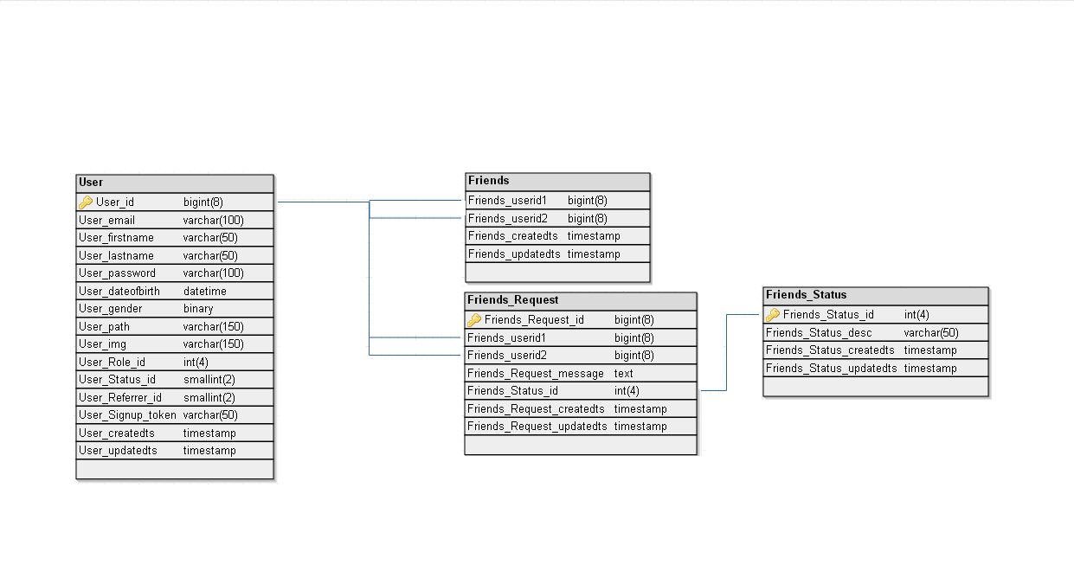

SQL query for the above table

CREATE TABLE `Friends` (
`Friends_userid1` BIGINT(8),
`Friends_userid2` BIGINT(8),
`Friends_createdts` TIMESTAMP NOT NULL DEFAULT '0000-00-00 00:00:00',
`Friends_updatedts` TIMESTAMP NOT NULL DEFAULT CURRENT_TIMESTAMP ON UPDATE CURRENT_TIMESTAMP

);

CREATE TABLE `Friends_Status` (
`Friends_Status_id` INT(4) NOT NULL AUTO_INCREMENT,
`Friends_Status_desc` VARCHAR(50),
`Friends_Status_createdts` TIMESTAMP NOT NULL DEFAULT '0000-00-00 00:00:00',
`Friends_Status_updatedts` TIMESTAMP NOT NULL DEFAULT CURRENT_TIMESTAMP ON UPDATE CURRENT_TIMESTAMP,
PRIMARY KEY (`Friends_Status_id`)
);

CREATE TABLE `Friends_Request` (
`Friends_Request_id` BIGINT(8) NOT NULL AUTO_INCREMENT,
`Friends_userid1` BIGINT(8),
`Friends_userid2` BIGINT(8),
`Friends_Request_message` TEXT,
`Friends_Status_id` INT(4),
`Friends_Request_createdts` TIMESTAMP NOT NULL DEFAULT '0000-00-00 00:00:00',
`Friends_Request_updatedts` TIMESTAMP NOT NULL DEFAULT CURRENT_TIMESTAMP ON UPDATE CURRENT_TIMESTAMP,
PRIMARY KEY (`Friends_Request_id`)
);

ALTER TABLE `Friends` ADD CONSTRAINT `Friends_fk1` FOREIGN KEY (`Friends_userid1`) REFERENCES User(`User_id`);
ALTER TABLE `Friends` ADD CONSTRAINT `Friends_fk2` FOREIGN KEY (`Friends_userid2`) REFERENCES User(`User_id`);

ALTER TABLE `Friends_Request` ADD CONSTRAINT `Friends_Request_fk1` FOREIGN KEY (`Friends_userid1`) REFERENCES User(`User_id`);
ALTER TABLE `Friends_Request` ADD CONSTRAINT `Friends_Request_fk2` FOREIGN KEY (`Friends_userid2`) REFERENCES User(`User_id`);
ALTER TABLE `Friends_Request` ADD CONSTRAINT `Friends_Request_fk3` FOREIGN KEY (`Friends_Status_id`) REFERENCES Friends_Status(`Friends_Status_id`);

